**PRODUCT SERVICE :**

1. **Get All Products (Get Mapping)**

localhost:8765/product OR localhost:8100/product

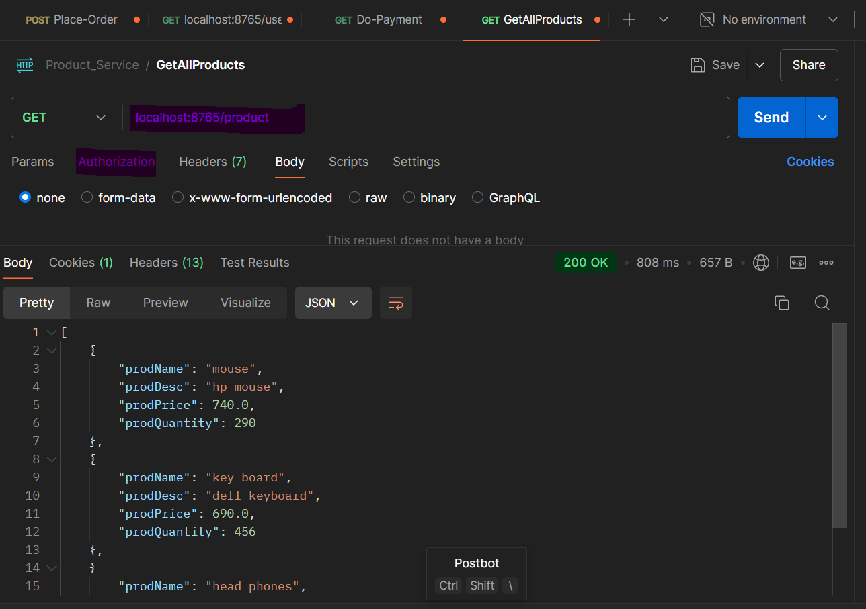

1. **Get Product By Id (Get mapping)**

1. **Add A Product (Post Mapping)**

localhost:8765/product (Auth) OR localhost:8100/product

1. **Get Product By Filter (Get Mapping)**

localhost:8765/product/filter?prodName=m&prodPrice=740 OR localhost:8765/product/filter?prodName=m&prodPrice=740

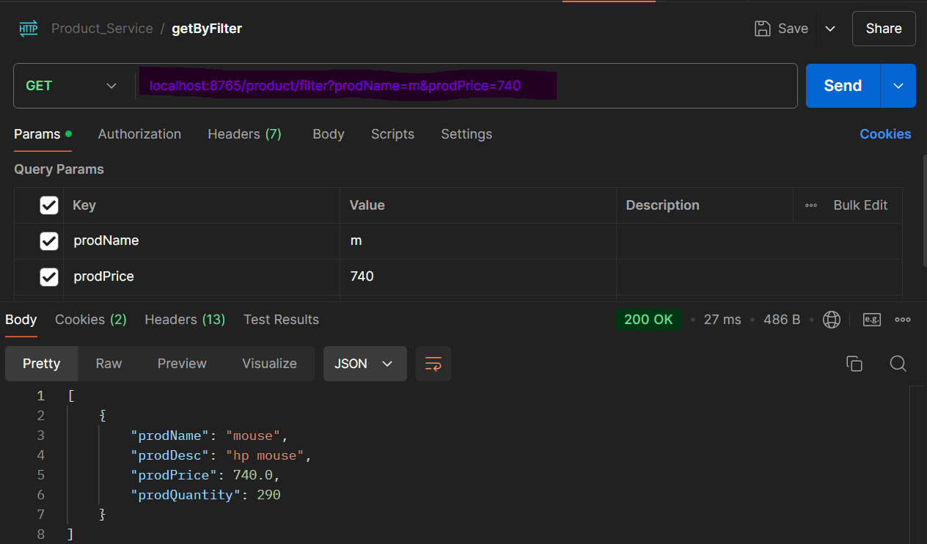

1. **DELETE by Id (Delete Mapping)**

localhost:8765/product/2(auth) OR localhost:8100/product/2/

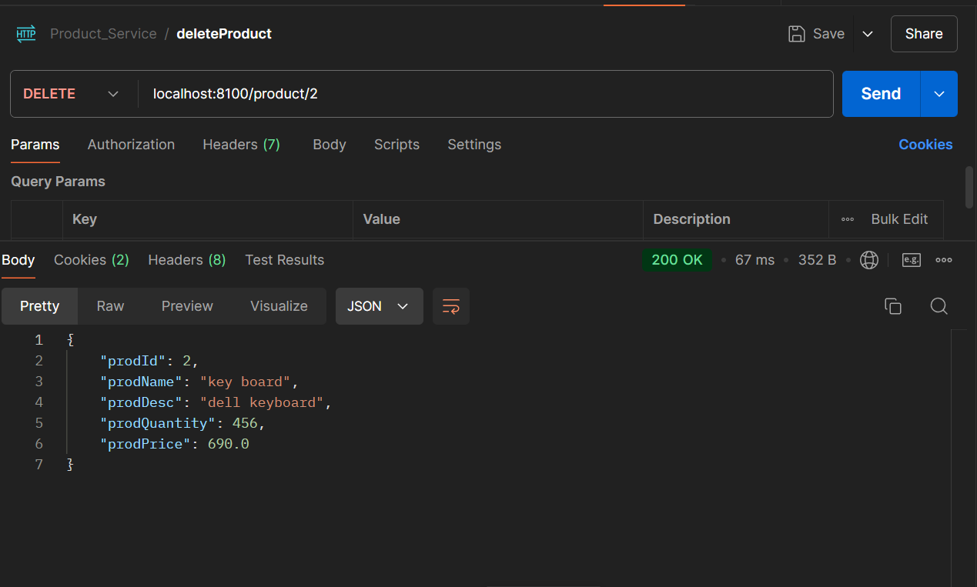

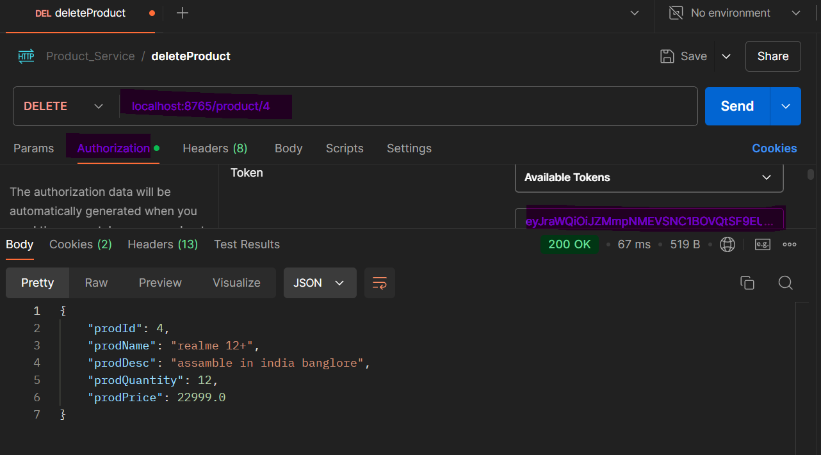

1. **Update Product (PUT mapping)**

localhost:8765/product OR localhost:8100/product/2

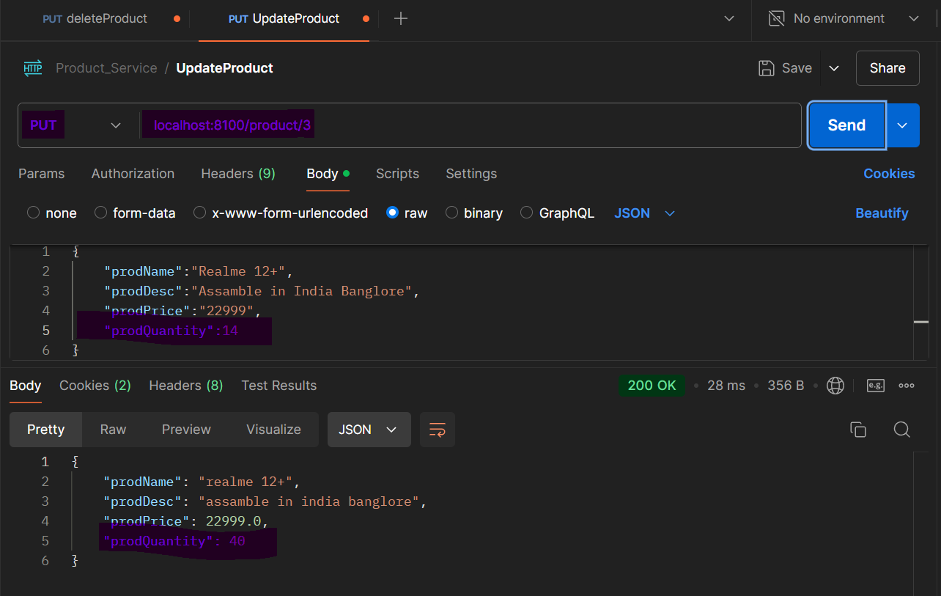

1. **Get All Products (PUT mapping)**

localhost:8765/product OR localhost:8100/product/2

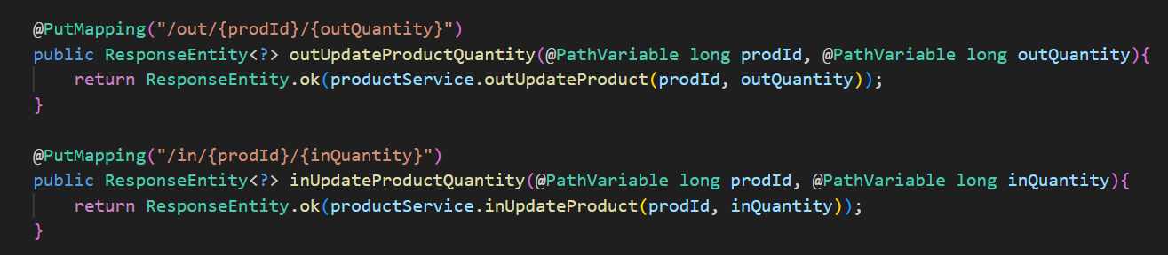

Changes only quantity by in or out quantity

Methods for order service

(Okta is not implemented in product service)

**PAYMENT SERVICE :**

1. **Get All Payment of a user (Get Mapping)**

(Okta is implemented in product service)

localhost:8765/payment/user/1 localhost:8400/payment/user/1

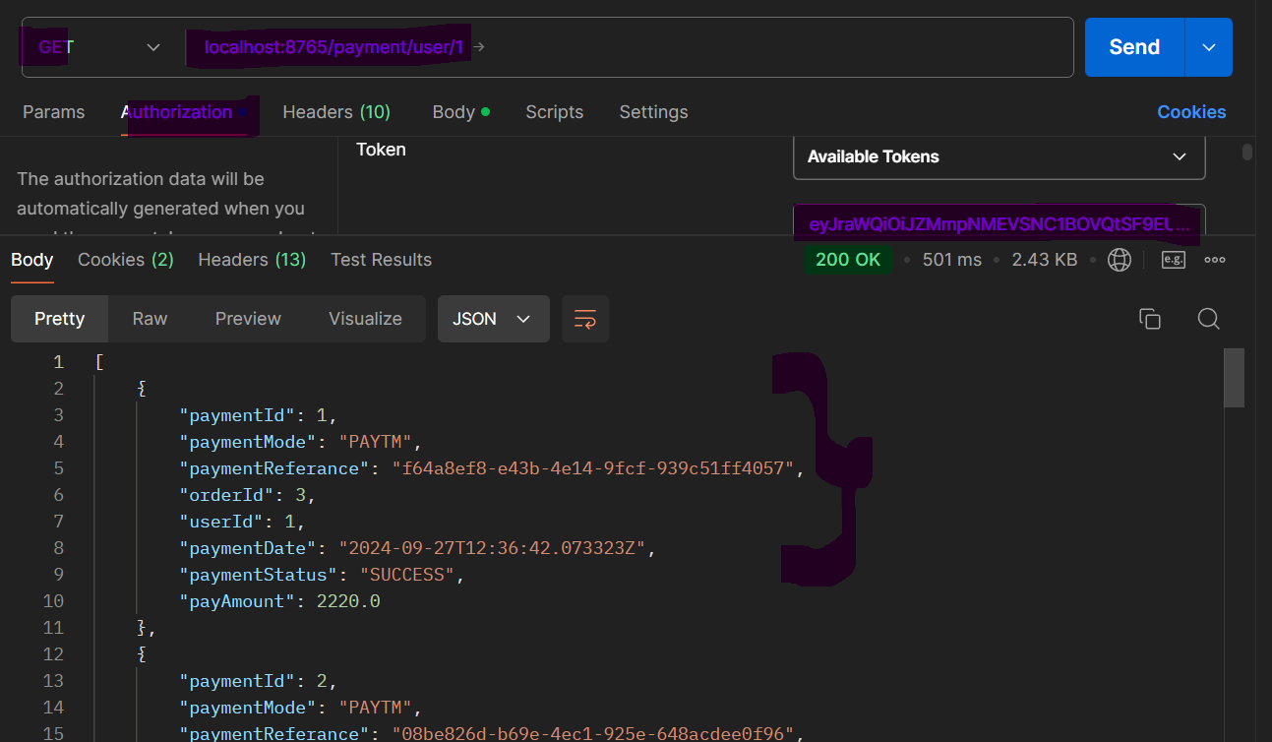

1. **Get Payment by Payment Id (Get Mapping)**

localhost:8765/payment/1 localhost:8400/payment/1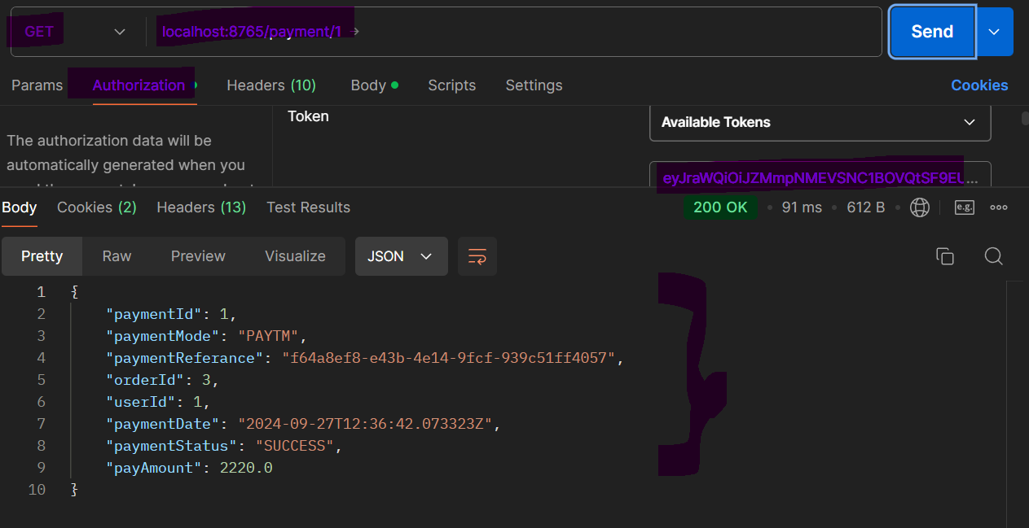

1. **Do a payment (POST Mapping)**

localhost:8765/payment/do localhost:8400/payment/do

1. **Undo a payment-by-payment Id (POST Mapping)**

localhost:8765/payment/undo/1 localhost:8400/payment/undo/1

1. **Do a payment (POST Mapping)**

localhost:8765/payment/pay localhost:8400/payment/pay

Used from order Service

**USRE SERVICE :**

1. **Get All Users (Get Mapping) (ADMIN auth needed)**

(Okta is implemented in product service)

localhost:8765/user

localhost:8300/user

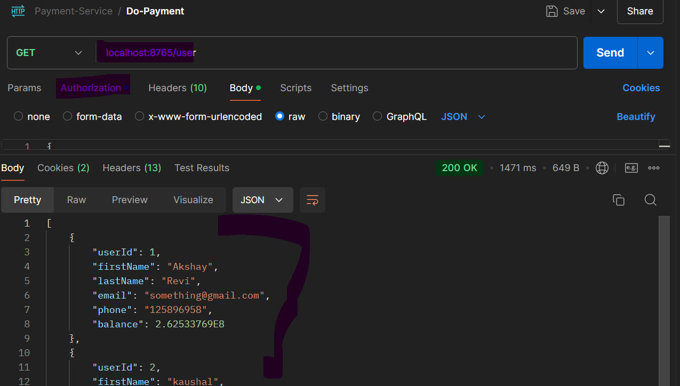

1. **Get a user by user Id (Get Mapping)**

localhost:8765/user/1

localhost:8300/user/1

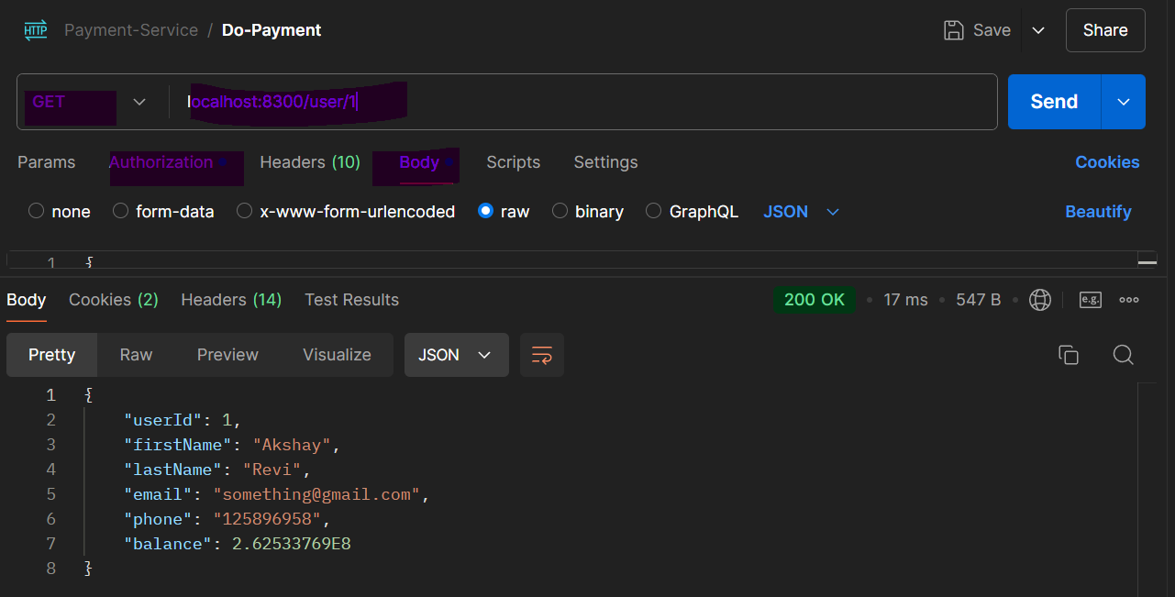

1. **Add a user (Post Mapping) (Admin auth needed)**

localhost:8765/user/1

localhost:8300/user/1

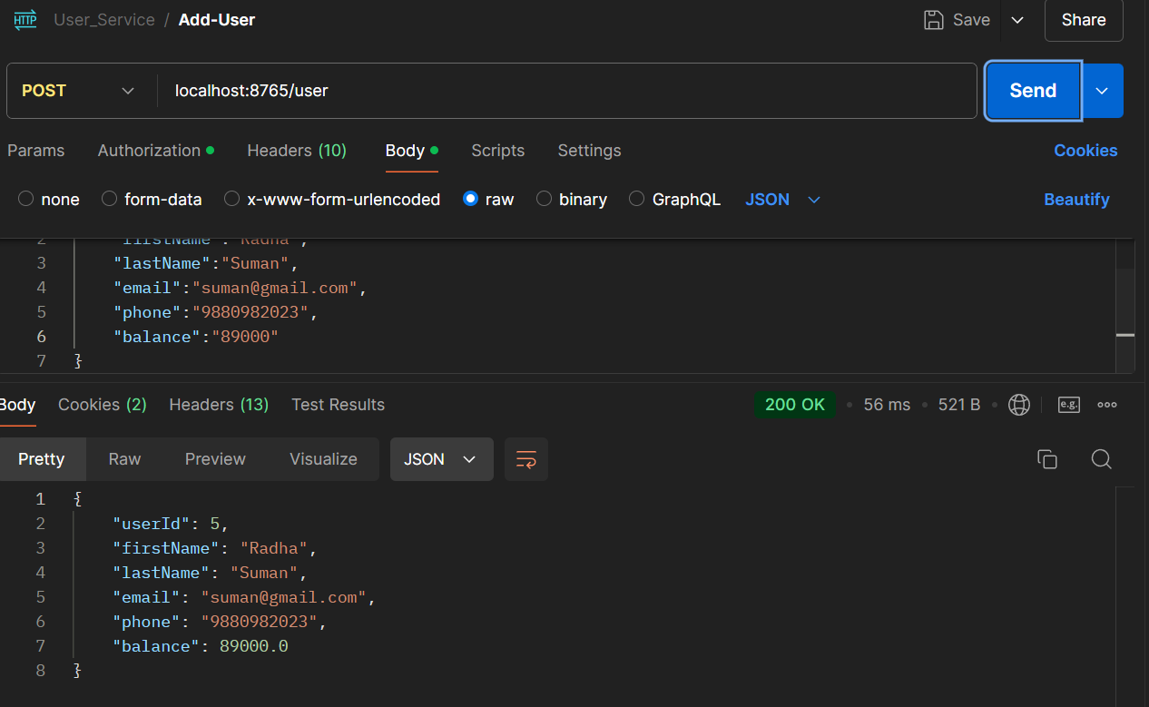

1. **Delete a user by User Id (Delete Mapping)- (Admin auth needed)**

localhost:8765/user/1

localhost:8300/user/1

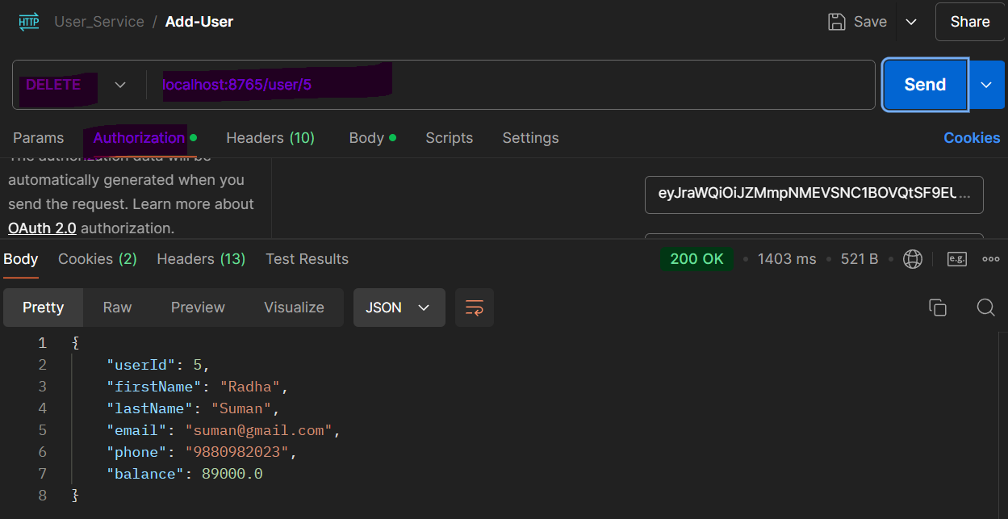

1. **Delete a user-by-User Id (put Mapping)- (Admin auth needed)**

localhost:8765/user/1

localhost:8300/user/1

(user Name from Radha to Radhika)

1. **Add balance to a user-by-User Id (put Mapping)-**

localhost:8765/user/addbalance/6?balance=9000

localhost:8765/user/addbalance/6?balance=9000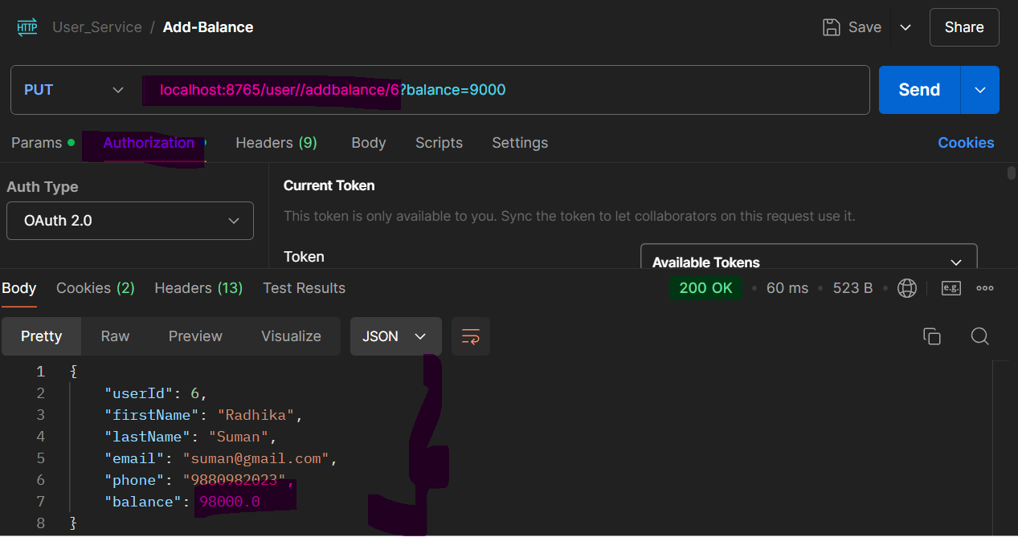

1. **Get All Orders or a User (Get Mapping)-**

localhost:8765/user/orders/1

localhost:8765/user/orders/1

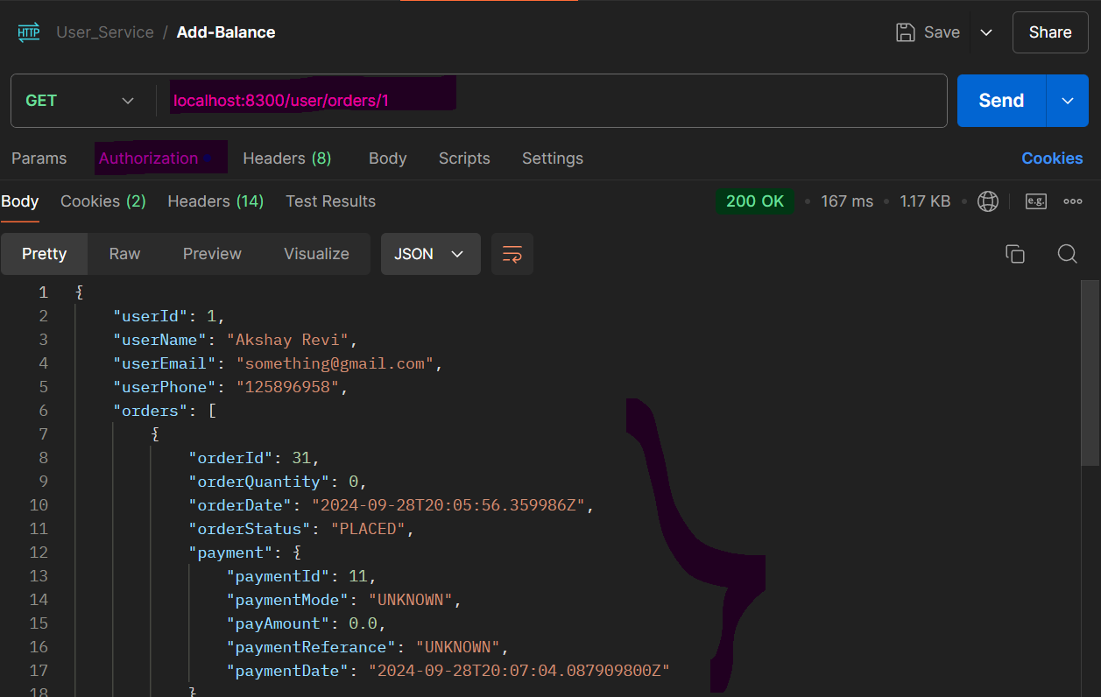

1. **Get All Payments or a User (Get Mapping)-** localhost:8765/user/payments/1 localhost:8765/user/ payments/1A screenshot of a computer program

   Description automatically generated

Do means – reducing balance (Successful Order)

Undo means – adding back balance of a payment id (cancel the order)

Get Balance – to check If user can place order or not (enough money)

**ORDER SERVICE :**

1. **Place Order**

(Okta is implemented in product service)

localhost:8765/order/place-order

1. **Delete a order (that mean cancel and return money to user and increase product quantity)**

localhost:8765/order/delete/35

1. **Get order by id**

localhost:8765/order/35

localhost:8200/order/35

1. **Get All orders of a user**

localhost:8765/order/orders/1

localhost:8200/order/orders/1

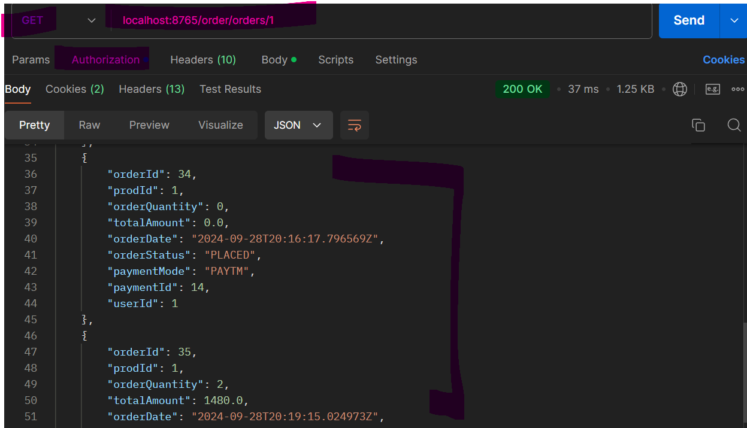

**API GATEWAY**

<http://localhost:8765/authenticate/login\>

